**VOYAGE VISTA: ILLUMINATING INSIGHTS FROM UBER EXPEDITIONARY ANALYSIS**

**1 INTRODUCTION**

1.1 Overview

Uber is a multinational transportation network company that operates a ride-hailing platform. It was founded in 2009 by Garrett Camp and Travis Kalanick and is based in San Francisco, California. Uber provides a convenient way for individuals to request rides from drivers who use their own personal vehicles.

1.2 Purpose

Taking numbers, statistics, and digital metrics ad transforming them into actionable insights, we utilize machine learning, Al , natural language processing, and advanced statistical modeling to implement automations and algorithms that enhance safety , amplify performance, improve our customer experience across Uber,...

What can be achieved using this?

The company has over 131 million monthly active users and 6 million active drivers and couriers worldwide and facilitates an average of 25 million trips per day. It has facilitated 42 billion trips since its inception in 2010 and is the largest ridesharing company in the United States. Uber Technologies, Inc.

**2 Problem Definition & Design Thinking**

2.1 EMPATHY MAP

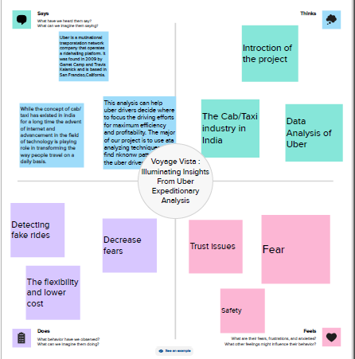

2.2Ideation & Brainstorm Map

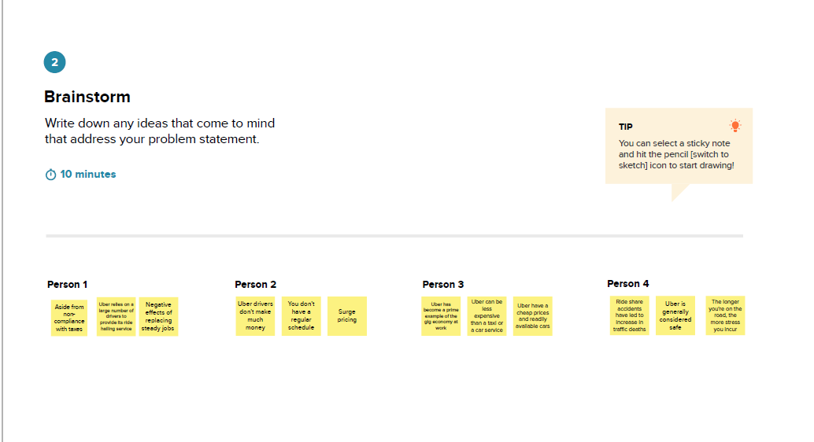

**3 RESULT**

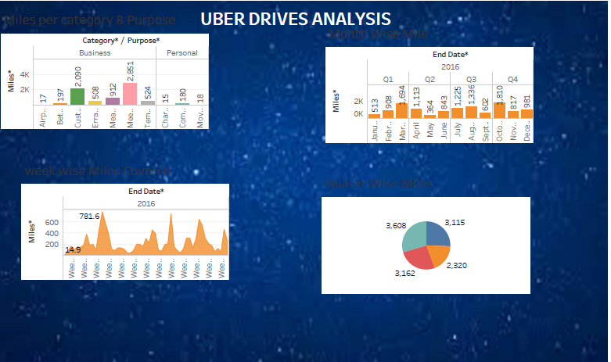

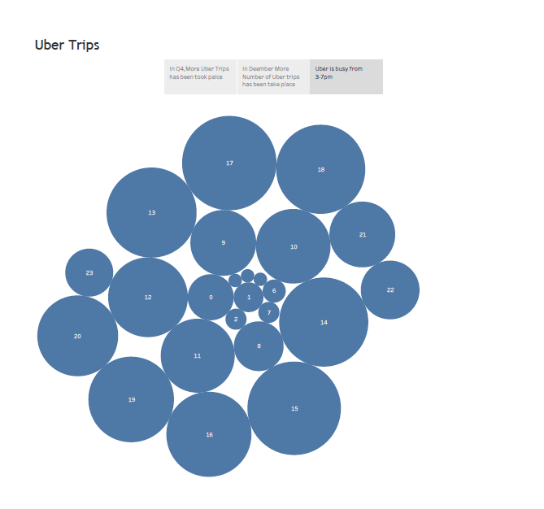

**4 ADVANTAGES & DISADVANTAGES**

**Advantages of Uber:**

Convenience: Uber offers a convenient and user-friendly way to book rides. Users can request a ride with a few taps on their smartphones, eliminating the need to hail a taxi or wait for public transportation.

Availability: Uber operates in many cities and regions, providing riders with access to transportation options even in areas where traditional taxis may be scarce.

Safety Features: The Uber app provides features like real-time tracking of rides, driver information, and the ability to share trip details with trusted contacts for safety.

**Disadvantages of Uber:**

Safety Concerns: While Uber has implemented safety features, incidents involving rider/driver safety have occurred, raising concerns about the screening and monitoring of drivers.

Accessibility: Uber may not be accessible to everyone, particularly those without smartphones or internet access.

**5 APPLICATIONS**

Tackling problems like poor transportation infrastructure in some cities, unsatisfactory customer experience,late cars,poor fulfilment, drivers denying to accept credit cards and more-Uber has “eaten the world” in less than 5 years and is a remarkable name to reckon when it comes to solving problems for people in .. …

**6 CONCLUSION**

Uber Technologies,Inc.(commonly referred to as Uber) provides ride-hailing services,food delivery,and freight transport. It is headquartered in San Francisco and operates in approximately 70 countries and 10,500 cities worldwide.

**7 FUTURE SCOPE**

The company expects by 2021, around 539.49 millionusers will use its taxi services. The tremendous success of Ubr can be attributed to its simple and unquie business model and its ability to offer an easy cab booking experience to customers with diverse transportation needs.